P200-How to establish the power line network in different rooms for Internet

Product line: powerline question category: Internet setup

- Connect the devices.
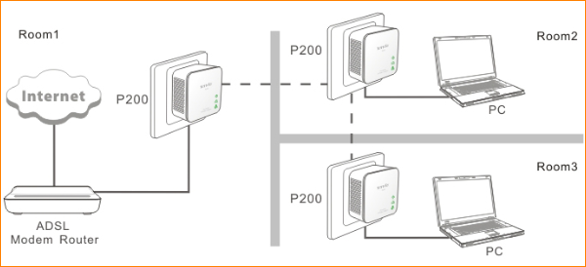

Tips: If the two adapters have intercommunicate to each other, the PLC light of them should be on.
Attention: Only when the wall outlets work in the same electric meter, can the adapters establish a power line network.

2. After the connection like above, P200 will pair to each other automatically. The computer or other device that connect to P200 can have Internet.

- If you want to add more P200 to this power line network just plug it into the wall outlet that in the same electric meter of the other P200, then it will join the power line network automatically.

